RSO TEST SET MANUAL

INTRODUCTION TO RSO TESTING

1. RSO Techniques

The Repetitive Surge Oscillograph (RSO) equipment produces a succession of steep-fronted low voltage pulses which are injected simultaneously into the two ends of a rotor winding. The voltage applied to the winding is in the range 5-10V. Discontinuities in the surge impedance of the winding produce reflections which appear at the point of injection and modify the voltage monitored at that point. (Discontinuities in the surge impedance are produced by inter-turn faults, earth faults or breaks in the winding). By monitoring the voltages at both injection points on a dual-beam oscilloscope and superimposing the traces, differences in the two voltages (caused by a discontinuity in one pole of the winding) are immediately apparent. In order to enable small voltage differences to be detected more easily the two voltages are also subtracted electronically and the difference voltage displayed. If no discontinuities are present the resultant trace is a straight line, a discontinuity showing as a deviation from the straight line.

2. Location of Fault

On a complete rotor (ie with endbells fitted) fault location can only be carried out empirically. The injected pulses do not travel through the winding at a constant velocity but gradually decelerate, the equation relating transit time and winding length traversed being derived by measurement. The equation takes the form:

T = AL + BL²

where T is the transit rime in microseconds, and L is the per unit winding length traversed.

For fault location purposes the transit time measured is the time taken for a pulse to travel from one slipring to the fault location, and for its reflection to return to the point of injection. Thus the distance travelled in the time measured is twice the distance of the fault from the start of the winding.

This is shown in Appendix 1 where the propagation equation for a typical rotor is plotted and the winding coil locations can be superimposed on the length scale.

Thus the location of a fault can be assessed with reasonable accuracy by measuring the time delay between the injection of the pulse and the appearance of the reflection. This delay time can then be related to the fault location using a graph.

(Re-copy and update of paper by W T Stokes 20th July, 1978) Version 2.3
1
GENERATOR TEST DEPARTMENT
TEST INSTRUCTION 3/79
REPETITIVE SURGE TESTING

RSO tests are required on all cylindrical rotors at the following stages of manufacture.

- After bake-out. To be taken when all pressing gear is fitted and the rotor is hot.

- After wedging.

- After fitting endwinding packings.

- After fitting endbells.

- During balancing.

- On final works test.

PROCEDURE FOR RSO TESTING

1. Equipment Needed

RSO Pulse generator
Pico two channel Oscilloscope
Laptop running a copy of Pico Scope.
The Pico Scope software is available on the included USB stick or at www.picotech.com/downloads
Multi-plug and extension lead
Interconnecting leads

2. Setting Up – (Using Pico Scope meter)

2.1 Connect CH A & CH B leads from RSO to oscilloscope

2.2 Set the oscilloscope sensitivities to 2 volts/div which is the 10v selection on the Pico Scope software. Select the time base to 5 microseconds/div. Select Trigger Source to CH1 and “/” slope (or alternatively connect cable to EXT. TRIG, and set scope for +ve slope).

Make sure the threshold is set to around 1v and that the scope is running; the play button on the bottom left.
Another option is to use the rso.psdata configuration file located on the USB stick.

2.3 Switch on the Pulse Generator and displayed traces should be identical and show a steep fronted pulse of about 8 to10 volts amplitude, decaying smoothly to zero.

3. Test Procedure

3.1 Records

Records are be kept of all RSO tests. Use relevant site check sheet pertaining to specific oscilloscope used and generator rotor under test.

  - Connection to Rotor

- The connections between the pulse generator and the rotor under test shall be made by means of coaxial cables of equal length, the braid of the coax being connected to the rotor shaft.

2

3.2 Connection to Rotor

2. On rotors with sliprings, connect socket INNER to the inboard slipring and socket OUTER to the outboard slipring. The trace monitored at the inboard slipring will appear on oscilloscope CH A.

3. On rotors without sliprings connect socket INNER to a pole that can easily be identified (preferable by a stamped datum mark) and connect socket OUTER to the other pole. Record the chosen datum mark on the record sheet.

3.3 Adjustment of Source Impedances

- Disconnect plug from socket OUTER.

- Adjust RV1 until trace on CH A is half the amplitude of that on CH B.

Use the Pico Scope measurement facility, the rulers have grab ‘handles’, find them at the bottom left and right hand side of the screen.
Add a measurement (bottom right of the screen and select a channel and select peek-peek measurement type.

- Reconnect plug to socket OUTER.

- Adjust RV2 until the two traces are equal in amplitude.

- Record value of RV1 and RV2 in results document.

Pico scope also has a notes feature that you can use to make notes and record RV1 and RV2.

3.4 Measurement of Propagation Time

- Remove plug from oscilloscope CH B.

- Transfer plug from socket OUTER to oscilloscope CH B.

- Set sensitivities to 1V/div or the (5v selection on the Pico Scope Software) CH A. 2V/div or 10v selection on the Pico Scope. CH B.

10 microseconds/div. for a direct cooled winding or
20 microseconds/div. for an indirect cooled winding.

- Position the traces so that CHA is above CHB on the oscilloscope screen. Save the waveform as Trace 1.

On Pico scope select the CH B icon ensure the DC offset is 0, then select channel A and increase the DC offset, until A is sufficiently above B.

To save the image, select edit => Copy Image, then save the image in Word or Paint Brush.

- Record the time for a single transit of the winding from CH B and for a double transit from CHA.

- Transfer plug from oscilloscope CH B to socket OUTER.

- Reconnect plug from pulse generator to oscilloscope CH B.

- Set sensitivities to 1V/div or 5v selection on the Pico Scope software. Increase the time-base sensitivity by a factor of 2, so for example 20µ Seconds becomes 10µ Seconds.
3

3.5 Location of Faults

1. Position the traces so that CH A is above CH B on the oscilloscope screen. Save the waveform as Trace 2.

- Superimpose the traces carefully. Save the waveform as Trace 3.

On Pico scope select the CH B icon ensure the DC offset is 0, then select channel A and increase the DC offset, until A is sufficiently above B.

- Select differential input ie CH A - CH B to show the differences between traces. The differences should very minor for a good rotor as shown in Appendix A. Save the subtracted waveform as Trace 4

On the Pico scope, select the Math function by navigating to Tools=>Maths=>A-B

- Set the sensitivities of both channels to the same value in the range 1V/div - 5v selection on the Pico Scope software. but ensure that the oscilloscope is not overloaded.

- Locate any discontinuities by measuring the time interval from the start of the trace to the appearance of the reflection and record on the test sheet.

- For ease of reporting the trace files are saved in bitmap format which can be easily inserted in test report ie DMS RSO Procedure document 10000007473.

Appendix A
SIMULATED ROTOR FAULT

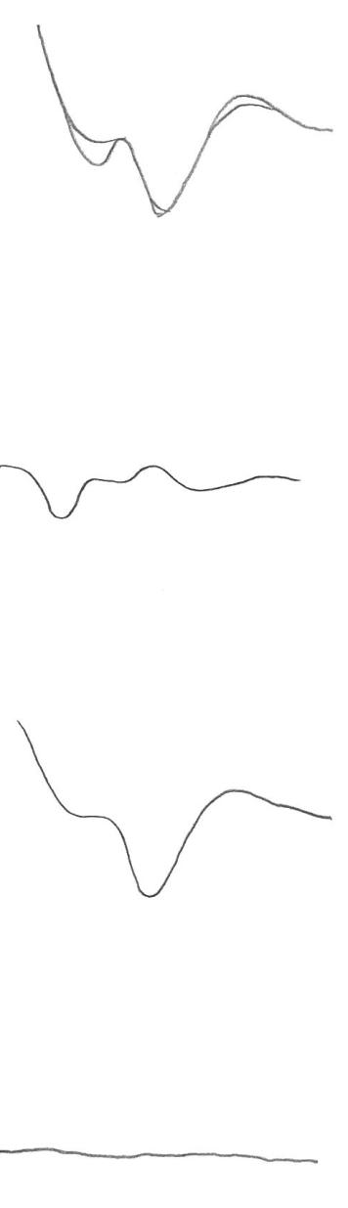 | - Superimposed traces – inter-turn fault on coil  - Subtracted trace – inter-turn fault on coil  - Superimposed traces – healthy rotor.  - Subtracted trace – healthy rotor.

Appendix B

TYPICAL TRACES OBTAINED ON A 2 POLE 11MW GENERATOR ROTOR

Trace 1 – Propagation Time

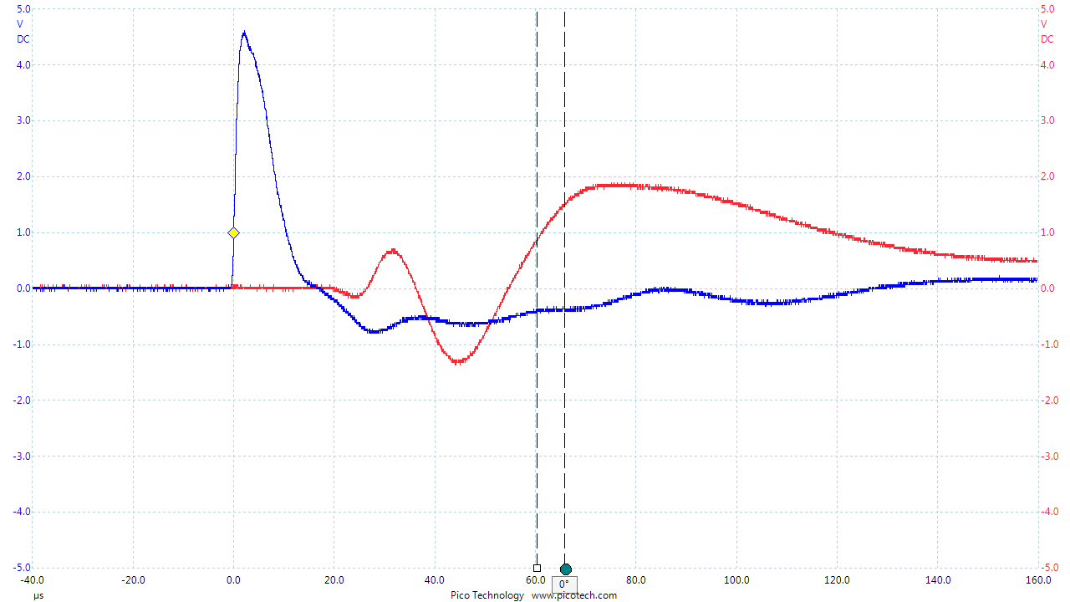

Trace 2 – CH1 Above CH2

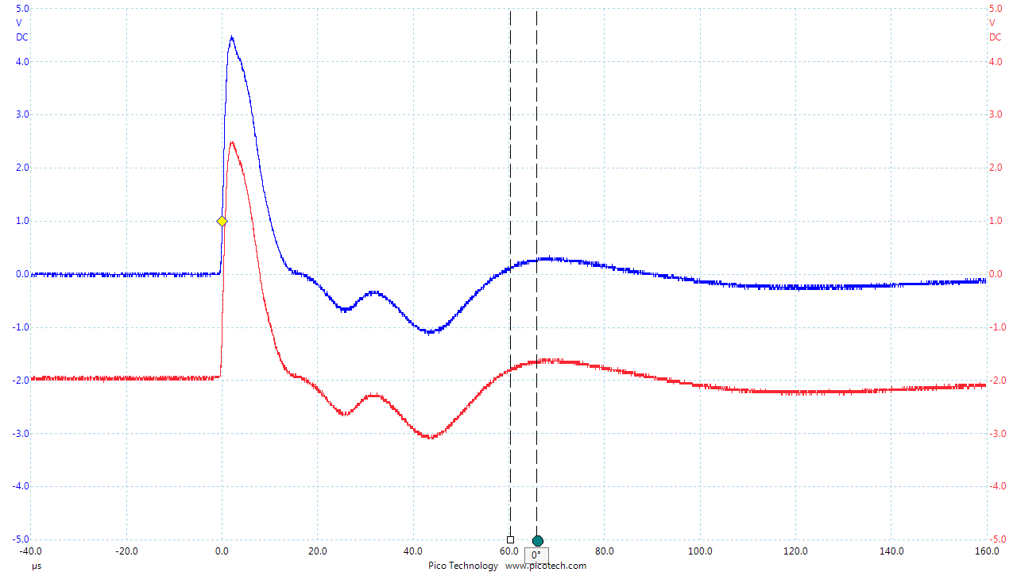

Trace 3 - CH1 Superimposed On CH2

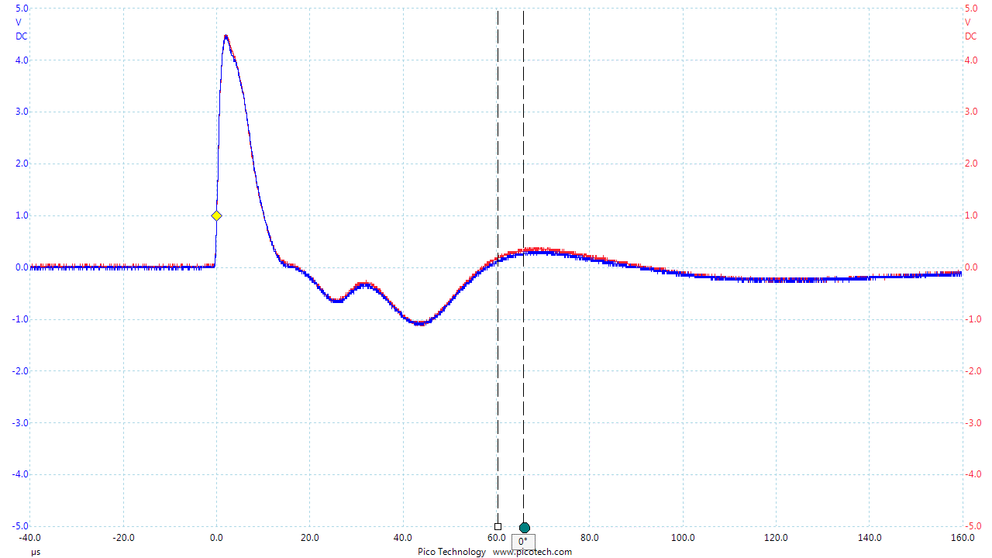

Superimposed with Math function turned on
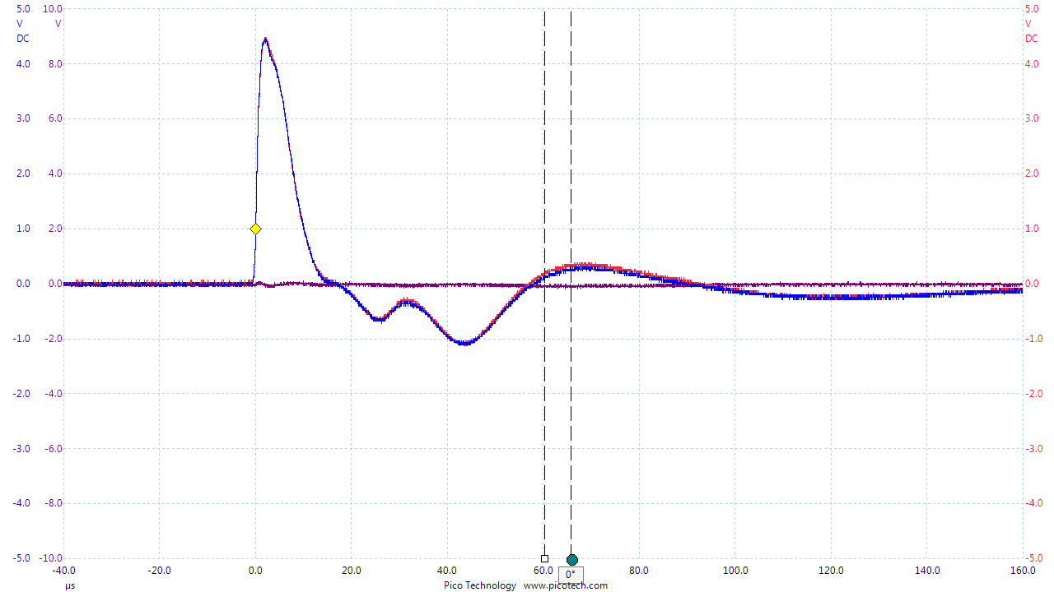

Appendix C

